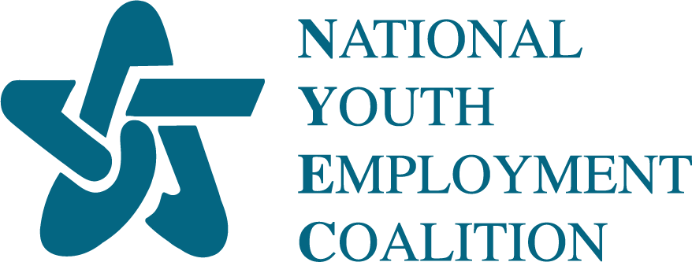

**National Youth Employment Coalition’s 2024 Youth Days**

**Social Media Toolkit**

**Get the word out about our upcoming event, Youth Days in Washington D.C.!**

Join us for the National Youth Employment Coalition’s 2024 Youth Days in Washington D.C. on September 11-13! This toolkit is designed to help you promote the event on your social media channels and in newsletters. Below, you will find sample posts, images, and a newsletter blurb. Thank you for helping us spread the word! ***Banner Images for use located at the bottom of the toolkit.***

### **What, Where, When, Why**

* **What:** NYEC 2024 Youth Days - a hybrid event to advocate for Opportunity Youth
* **Where:** Washington D.C. (with virtual training sessions prior to the event in August)
* **When:** September 11-13, 2024
* **Why:** To empower practitioners, community and organization leaders, and young people to advocate for Opportunity Youth at the federal level
* **Learn More:** <https://nyec.org/youthdays2024/>

### **Sample Newsletter Blurb**

Join the National Youth Employment Coalition’s 2024 Youth Days in Washington D.C. on September 11-13, where practitioners, community and organization leaders, and young people will advocate for Opportunity Youth at the federal level! This hybrid event will host virtual training sessions on holding effective meetings with policymakers to prepare participants for their Hill meetings in September! Whether you are new to policy or a seasoned advocate, you will not want to miss this event! Register: <https://nyec.org/youthdays2024/>

 **Twitter/ X Social Media**

* Excited for @TheNYEC’s 2024 Youth Days in D.C., Sept 11-13! Advocate for #OpportunityYouth, join virtual trainings, and prepare for Hill meetings. Register now: <https://nyec.org/youthdays2024/>
* Calling all youth advocates! Join us for @TheNYEC’s 2024 Youth Days in Washington D.C. from Sept 11-13. Learn, connect, and advocate for #OpportunityYouth. Secure your spot today: <https://nyec.org/youthdays2024/>
* Join @TheNYEC for 2024 Youth Days in D.C.! Start with virtual sessions from August-September, then meet in person Sept 11-13 to prep for legislative meetings. Be empowered, engage with stakeholders, and amplify your voice. Register: <https://nyec.org/youthdays2024/>

 **LinkedIn**

* The National Youth Employment Coalition invites everyone to join the 2024 Youth Days in Washington D.C., September 11-13! This hybrid event will empower practitioners, community and organization leaders, and young people to advocate for Opportunity Youth at the federal level. Attendees will benefit from virtual training sessions on effective policymaker meetings and in person events including meetings on Capitol Hill. Register now and be part of this important event: <https://nyec.org/youthdays2024/>
* The National Youth Employment Coalition invites everyone to join the NYEC 2024 Youth Days in Washington D.C. This hybrid event will start with virtual sessions on August 19th through September 3rd  , including "Advocacy 101: Leading Effective Meetings with Policy Makers" and "Amplify Your Voice: Harnessing the Power of Social Media for Youth Advocacy." Then, community leaders, practitioners, and young people will come together in D.C. September 11th-13th for a final in-person prep session before meeting with legislators about the issues that are important to their communities. Don't miss this chance to be empowered, engage with stakeholders, and amplify your voice! Register today: <https://nyec.org/youthdays2024/>

 **Instagram**

* Join the National Youth Employment Coalition’s 2024 Youth Days in Washington D.C. on September 11-13! This hybrid event will bring together practitioners, community and organization leaders, and young people to advocate for Opportunity Youth at the federal level. Don’t miss out on inspiring virtual training sessions and impactful Hill meetings. Register now and be a part of this transformative event: <https://nyec.org/youthdays2024/>
* Join NYEC for the 2024 Youth Days in Washington D.C.! This hybrid event starts with virtual sessions on August 19th through September 3rd , covering topics like "Advocacy 101" and "Amplify Your Voice" before bringing community leaders, practitioners, and young people together in person from September 11-13 for impactful meetings with legislators. Register now and be part of the change: <https://nyec.org/youthdays2024/>

**Tag Us on Social Media!**

Help us spread the word about the NYEC 2024 Youth Days! Tag us on social media and use our handles:

* **LinkedIn:** [National Youth Employment Coalition](https://www.linkedin.com/company/national-youth-employment-coalition/?viewAsMember=true)
* **Twitter/X:** [**@**theNYEC](https://x.com/thenyec)
* **Instagram:** [The_NYEC_](https://www.instagram.com/the_nyec_/)

**Images:** Here are some images that you can use to promote 2024 Youth Days in Washington D.C event! Feel free to download and use them in your social media posts, newsletters and other promotional materials.

**2024 Youth Days Banner:**

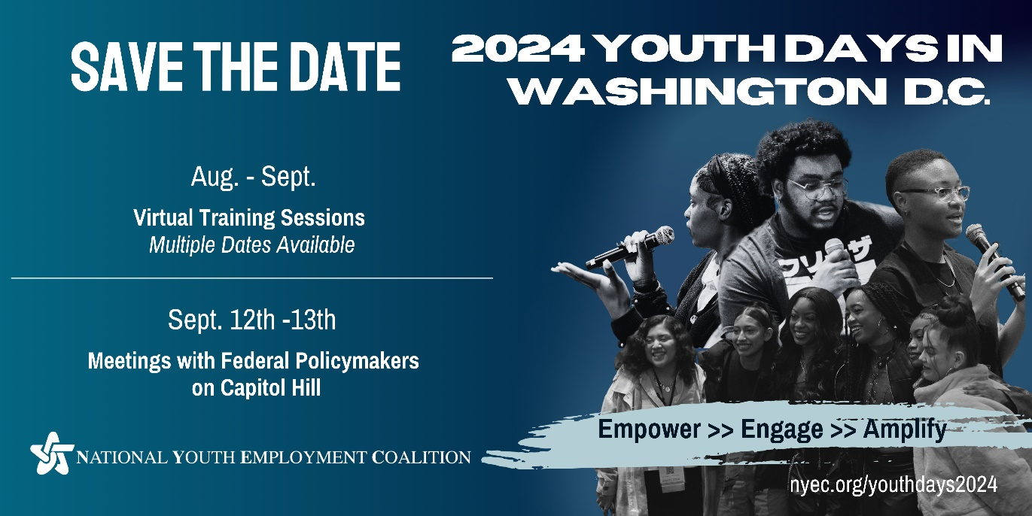

**Email Signature:**

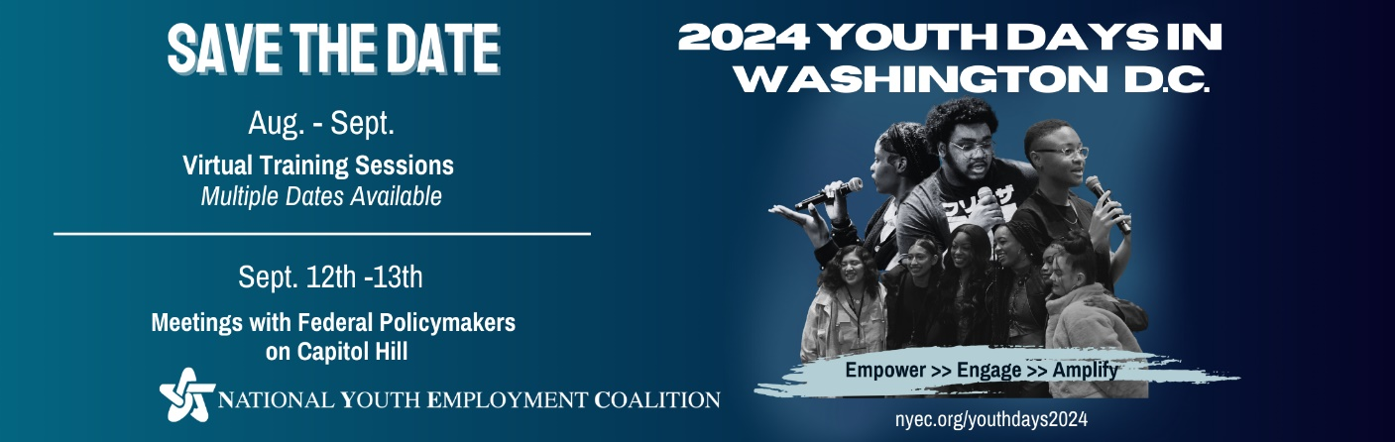

**Social Media post:**

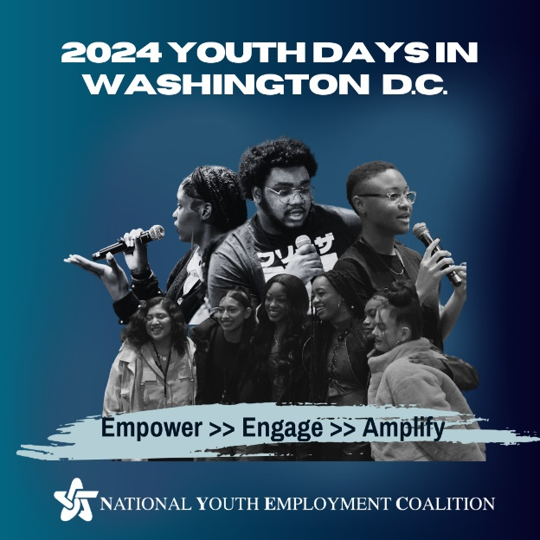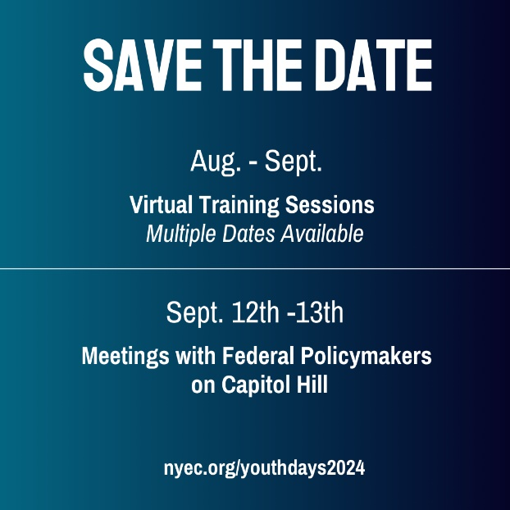

Thank you for helping us spread the word about the NYEC 2024 Youth Days! Your support and engagement are crucial in making this event a success. If you need any further assistance or have questions, please do not hesitate to contact us at [julia.frohlich@nyec.org](mailto:julia.frohlich@nyec.org) for communications or [cailee.fitzgerald@nyec.org](mailto:cailee.fitzgerald@nyec.org) for registration questions.

Thank you!

The National Youth Employment Coalition Team